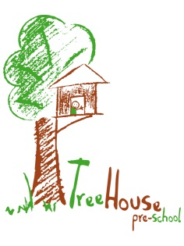
Key Person Policy

Statement of Intent
E.Y.F.S. commitment 2.4: “A Key Person has special responsibilities for working with a small number of children, giving them the reassurance to feel safe and cared for and building relationships with parents.”

Children are assigned to a Key Person when they begin attending TreeHouse Pre-school.

The key person system provides a secure base within the setting for the child from which he/she can happily discover the many positive aspects Treehouse has to offer.

The Key Person will take on the responsibility for monitoring the child’s progress. This will entail daily conversation with the child and observations, both formal and recorded, and informal, as well as regular information sharing with the child’s parent/carer.

Information gathered will be shared with the other staff so that decisions can be made about the most appropriate plan to meet the child’s needs and next steps.

Key Persons are responsible for collating their key children's learning journeys. Observations both written and photographic (where parental permission has been given) and samples of art work or mark making will be put into the child’s own Learning Journey.

Key Persons must keep Child Profiles up to date, showing the child’s development and progression. This information will be used to compile the overall monitoring on a half termly basis.

Key Persons must compile Play Plans for each of their key children every half term, these must then be shared with the child’s parents/carer on a half termly basis.

The key person is responsible for carrying out the two year old progress check on their key children aged two. This should be carried out as soon as possible, once the key person is confident they have sufficient knowledge and information on the child.
Key Persons will have one hour per key child every half term to keep records up to date.

In the event of a practitioner being absent for any reason each child has a Key share this person then takes on the responsibilities of the key person for the duration of their absence.

Key Persons will be supported at all times by the Pre-school management team.

All Treehouse staff will provide a high standard of care and education for all children in their care at all times.

Signed: ____________________________ Date: ___________________________
Position: ____________________________________________________________
Note: All Staff Members to sign overleaf, to confirm that they have read and understood this policy.

Staff Member | Signature | Date

