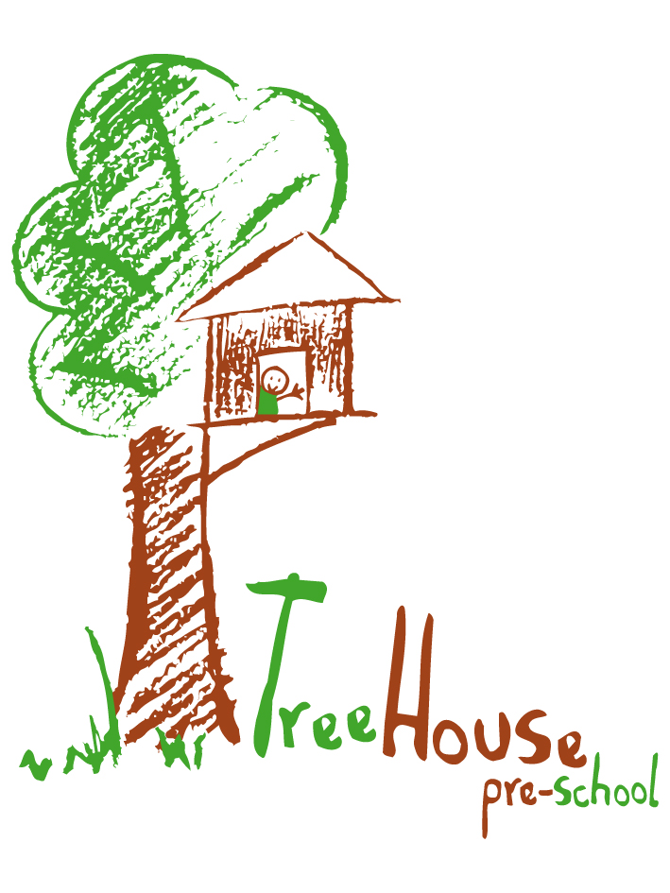

Equality
Of Opportunities Policy

EQUALITY OF OPPORTUNITIES POLICY

Statement of Intent
Treehouse Pre-school is committed to providing equality of opportunity and anti-discriminatory practices for all our children and families.
Aim
We aim to:
- Provide a secure environment in which all our children can flourish and in which all contributions are valued
- Include and value the contribution of all families to our understanding of equality and diversity
- Provide positive non-stereotyping information about different age groups, different ethnic groups and people with specific educational needs.
- Improve our knowledge and understanding of issues of equality and diversity; and
- Make inclusion a thread which runs through all of the activities of the pre-school
- Treehouse pre-school aims are to ensure that as soon as a concern is raised parents/carers should be contacted to discuss a child’s needs together, we aim to be there to listen to their views and any concerns they may have, their views will be taken into account regarding all areas of their child’s development. All discussions will be confidential.
The legal framework of this policy is:
- Race Relations Act 1976
- Race Relations Amendment Act 2000
- Sex Discrimination Act 1986
- Children Act 1989
- Special Educational Needs and Disability Act 2001
- Employment Equality (Religion & Belief) Regulations 2003
- Employment Equality (Sexual Orientation) Regulations 2003
- Employment Equality (Age) Regulations 2006
- Disability Discrimination Act (DDA) 1995 2005.

Methods
Admissions reference Admissions policy
Treehouse pre-school is open to all members of the community, everyone knows they are welcome.
We do this by:
- We provide information in clear, concise language, whether in spoken or written form.
- We provide information in as many languages as possible.
- We base our admissions policy on a fair system.
- We do not discriminate against a child with specific education needs or refuse a child entry to our pre-school because of any specific needs.
Employment
Refer to employment policy.
- Posts are advertised and all applicants are judged against explicit and fair criteria
- The applicant who best meets the criteria is offered the post, subject to references and checks by the DBS. This ensures fairness in the selection process. All job descriptions include a commitment to equality and diversity as part of their specifications
- We monitor our application process to ensure that it is fair and accessible.
Training

- We seek out training opportunities for all staff and volunteers to enable them to develop practices which enable all children to flourish
We review our practises to ensure that we are fully implementing our policy for equality and diversity
Valuing Diversity in Families
- We welcome the diversity of family life and work with all families
- We encourage children to contribute stories of their everyday life into the pre-school
- We encourage parents/carers to take part in the life of the pre-school and to contribute fully
- For families who have a first language other than English, we value the contribution their culture and language offer
We offer a flexible payment system for families of differing means
We will not tolerate threatening or abusive behaviour towards or between staff and families and all such incidents will be challenged and recorded and where necessary relevant outside agencies will be involved.
- We advertise our services widely
- We reflect the diversity of members of our society in our publicity and promotional materials.
- We develop an action plan to ensure that people with specific needs can participate successfully in the services offered by our pre-school and in the curriculum offered.

Food

- We work in partnership with parents to ensure that the medical, cultural and dietary needs of children are met (reference to parent partnership policy)
- We help children to learn about a range of food, cultural approaches to mealtimes and eating and respect the differences among them.

Curriculum
- The curriculum offered in the pre-school encourages children to develop positive attitudes to people who are different from themselves. It encourages children to empathise with others and to begin to develop skills of critical thinking.
- Differentiating provision within the curriculum to ensure each child receives the widest possible opportunities to develop their skills and abilities to develop to their full potential.
- Information on how the individual needs of a child age stage background are met
- Regularly seeking the views and feelings of children and their families
- Where possible the child is included at the review meetings.
- We will endeavour to take into account a child’s views and opinions in various ways, through observations to see what activities they enjoy, talking to parents to find out the child’s likes and dislikes. Children are offered choices through verbal or visual communication such as pictures, photo boards or by any other means of communication.
- Making children feel valued and good about themselves following the structure of every child matters. To feel safe and secure within the setting.
- Ensuring that children have equality of access to learning.
- Reflecting the widest possible range of communities in the choice of resources.
- Avoiding stereotypes or derogatory images in the selection of materials.
- Celebrating a wide range of festivals.
- Creating an environment of mutual respect and tolerance.
- Helping children to understand that discriminatory behaviour and / remarks are unacceptable.
- Ensuring that the curriculum offered is inclusive of children with specific educational needs.
- Ensuring that children whose first language is not English have full access to the curriculum and are supported in their learning.

Supporting children with Special Educational Needs.

Reference Statement

This S.E.N. Policy is written in response to the code of practice 2001 on the identification and assessment of Specific Educational Needs. Our setting has regard to this code and has written this policy outlining our practice and procedures

Inclusion Statement.

Treehouse Pre- School aims to provide a welcoming atmosphere for all children and their families. We value all children equally with all abilities and will endeavour to offer relevant support for identified needs.

Definition of A CHILD WITH Specific EDUATIONAL NEEDS.

Treehouse Pre- School recognise the DFES definition of SEN which states a child has a specific educational need if he/she has a learning difficulty which calls for specific educational provision to be made for him/her.

DEFINITION OF THE ROLE AND RESPOSIBILITIES OF THE SPECIAL EDUCATIONAL NEEDS CO-ORDINATOR ( SENCO. )

Nominated Person. Marion Mitchell and Sarah Laws

Date appointed September 2010

Qualifications Marion Mitchell:
DPP level 3, SENCO Initial Training – November 2009, SENCO Advanced Training - October 2010, Child Protection – March 2009, First Aid – May 2009, Autism in the early years – June 2011.
Sarah Laws:
DPP level 3, SENCO Initial Training - November 2010, Child Protection – November 2009, First Aid – November 2010, Foundation workshop Makaton - April and May 2011, Autism in the early years –June 2011, ECAT (Every child a talker) 2009- 2011 included: Adult –child interactions, Communication friendly environments, Language activities, Partnerships with parents, Knowledge of a child’s language development.

THE ROLE OF THE SENCO

The SENCO will keep parents/ carers informed at all times by discussing any action before it is taken with regard to their child’s specific educational need.
The SENCO will ensure parents/ carers are given copies of individual educational plans (IEPs) and other paperwork. Records of meeting will be made (see appendix-record of meeting) which will be signed by everyone concerned.
Meetings will be held on a regular basis to review the progress of their child. Records are kept of all meetings.
Confidentiality will be maintained at all times.

Information Gathering.

The SENCO has responsibility to have access and to have read and understood all information on children. (See appendix, Entry profile, Application form, Record of first meeting). This information goes into a file specifically for that child the child’s own record of achievement is added to this file. The information is kept in a central place which only staff have access to. The file contains initial concern forms, observations, Individual Education Plans and information about outside agencies who may be involved with the child.

OBSERVATIONS AND RECORD KEEPING.

Safeguarding Officer (staff) – Marion Mitchell
Safeguarding Officer (Committee – Kirstine Beeley
Our system of observations and record keeping, which operates in conjunction with parents/carers, enables the staff to monitor children’s needs and progress on an individual basis. All children identified as having a specific educational need will be monitored, information will be gathered by observations and where appropriate the Bucks Developmental Curriculum Record. A programme will be devised to meet the child’s needs. For every child within our setting who is on Early years action, Early years action plus or has a Statement will have an IEP(Individual Education Plan), this will be reviewed regularly with parents/ carers.

OUTSIDE AGENCIES.

Together with parents/carers we will share information and will work with outside agencies for the benefit of the child e.g. S.A.L.T. --- Speech and language therapy. It is the responsibility of the SENCO to liaise with professionals ensuring that information is shared between them and the child’s parents/ carers.
Any reports should be shared with relevant staff copied for parents/ carers and be kept in the appropriate place.

LIASING WITH OTHER EARLY YEARS SETTINGS.

Any that the child may attend as well as TreeHouse parental/carer permission will be sort and information collected

LIASING WITH THE LOCAL EDUCATION AUTHORITY.

This is done through Early years inclusion officer and regular links meetings.

SUPPORTING COLLEAGUES.

The SENCO will support and be a reference point for colleagues on all SEN. issues, including identifying and working with children who have a specific educational needs. At staff meetings there is opportunity to share information the SEN has gathered and to give feedback from meetings with outside agencies or Network groups by sharing relevant documents and new initiatives...

TRAINING

The SENCO will attend relevant training and will ensure that the information is shared with colleagues.

THE ROLE OF OTHER STAFF.

The staff will follow the guidance of the SENCO on SEN issues. The staff will support the SENCO in their role and respect confidentiality at all times. All staff should be involved with the settings policy and be fully aware of the settings procedures for identifying and making provision for children with specific educational needs.

THE ROLE OF THE COMMITTEE.

The committee will have regard for the code of practice when carrying out duties toward children with SEN.
The Committee will support the SENCO and staff and via the SENCO be made aware of SEN issues and where appropriate, consider provision of extra resources to support and benefit a child with specific educational needs, taking into account confidentiality

SUPPORT AVAILABLE WITHIN THE SETTING FOR ALL CHILDREN.

DDA statement and reference.

Making reasonable adjustments to the environment and resources indoors and out

Our setting is all on one level, we have a good sized out door area at the back the building with a grassed area and a tarmac area garden area. There is a ramp access to the front and back of the building. Access to sand and water play and a variety of resources both inside and out.
We have accessible toilets, also different sized toilets and wash hand basins
Different sized chairs can be provided
To have available suitable equipment that will encourage and support children with SEN.
We would seek advice from parents and appropriate agencies if any changes needed to be made to accommodate children with S E N.
We also use a picture timetable and P.E.C.S. ( picture exchange communication system).
Small group activities
1 to 1 sessions for short periods of time.

IMPLICATIONS FOR THE SETTING.

The SENCO will be given release time to talk to parents and attend trainings and meetings.
Also to write IEPs record information. All staff need time in staff meetings to assist in the writing of IEPs record outcomes and to produce resources needed to accommodate children with SEN.
COMPLAINTS.

We provide a complaints procedure and record all complaints. Refer to complaints policy

ACHIEVING POSITIVE BEHAVIOUR

Named person responsible for Co-ordinating behaviour is Sarah Laws and Susan Black
Clear and developmentally appropriate expectations for behaviour are key.
The environment is ordered, the children are free from the fear of being hurt or hindered.
All the children are treated as individuals with their behaviour managed in a way appropriate for them and their stage of development.
Positive expectations that children are kind, respectful, care for belongings, care for resources and care for living things and for each other.

ROLE OF BEHAVIOUR CO-ORDINATOR:

- Keep up to date with legislation, research and guidance on promoting good behaviour.
- Identify and access relevant sources of expertise and training on promoting positive behaviour to ensure a consistent response in the promotion of positive behaviour eg: Inclusion Team (EYCS)
- To keep a record of staff attendance at trainings/ staff meetings (see training log)
- Ensure all staff volunteers, students and parents are familiar with the settings behaviour policy and its guidelines for behaviour.

It is the responsibility of all the staff etc. to:

- Provide a positive role model of language and behaviour by treating one another with respect, care and courtesy at all times.
- Record and report all injuries and accidents appropriately eg bites (reference behaviour policy – strategies to promote positive behaviour.
- Praise and celebrate positive behaviours – Well done tree
- Ensure children understand it is their behaviour and not the child that is unacceptable.
- Recognise that in some cases a child’s specific educational need may affect their behaviour, where this is appropriate staff will liaise with the Inclusion team.

Monitoring

To ensure our policies and procedures remain effective we will monitor and review them annually to ensure our strategies meet the overall aims of the Equality Of opportunity policy in promoting equality and inclusion and in valuing diversity
- It is the responsibility of all staff to report all incidents of discrimination to the leader who will make clear the unacceptability of the behaviour and attitudes and take appropriate action.

IMPLICATION OF POLICY.

This policy was adopted by the committee and agreed by all members of staff. It will be reviewed every year and in response to information in the new code of practice.

REVIEW DATE

December 2013

Signed by.

On behalf of the Treehouse Pre- School Committee.

POLICY LINK

Admissions policy
Parent partnership policy
Employment policy
Complaints policy
Behaviour policy
Medicine policy
Settling in policy
Health & Safety

